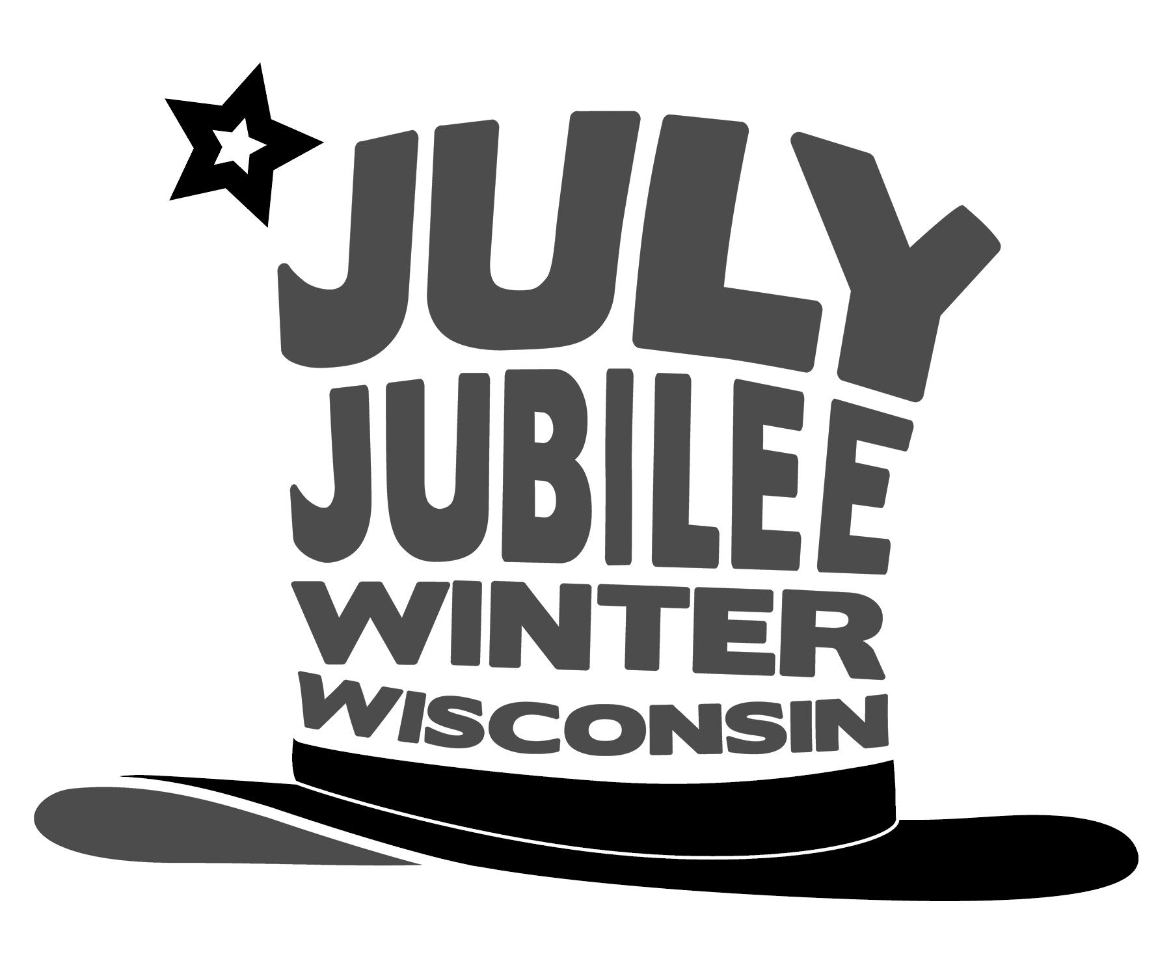
2026 July Jubilee

4th of July Celebration

Hello! WE ARE CELEBRATING 250 YEARS OF AMERICA!
It is the time of year where we start preparing for our annual 4th of July celebration. We are writing to you regarding your advertisement and sponsorship. The advertising goes on the poster that we distribute in Sawyer County and beyond. Add in a sponsorship and your name shows up on an individual 2’ x 3’ banner that is displayed in Doc Smith Park, on our website and a shout out on our Facebook page.

Your contribution is what makes this annual event so successful. It helps reduce costs from the fireworks to the live and musical entertainment to the parade and all the other activities everyone can enjoy.

We are hoping that we can once again count on you to support this annual and fun event.

If you have any questions, suggestions or would like to volunteer please contact Kris Treland (715)558-2796 or Rachel Barnaby (715)492-0002

Thank you for your support,
The July Jubilee Committee

__________________________________________________________________________

July Jubilee Advertisement Form

_____Option 1: $40 Poster-Business/Organization name listing on the 4th of July events poster.
_____Option 2: $175 Includes events poster, 2’x3’ banner (already printed), Facebook and website.
_____Option 3: t
_____Additional Donation

Business name as you’d like printed: _______________________________________

Submit this form and payment by February 28th, 2026:
July Jubilee Committee, P.O. Box 245, Winter, WI 54896
OR go to winterwi.com, Click the Events dropdown, select July Jubilee and click on the Sponsorship button

